Group 4’s Model Sequence Diagrams ADAV System Final Report

Behavioral Report – Sequence Diagrams

Author: Men at Work: Maxwell Polley, Ryan Patton, William Symolon, Joseph Mitchell

Revision: 0.1

|  |  |
| --- | --- |
| No Magic |  |
| One Allen Center, 700 Central Expressway South, Suite 110 Allen, Texas 75013 USA | Date: May 03, 2020 |

**Revision History**

|  |  |  |  |
| --- | --- | --- | --- |
| **Revision** | **Date** | **Description** | **Author** |
| 0.1 | 05/03/2020 | Behavioral Report – Sequence Diagrams Initial Draft | Men at Work |

**Table of Contents**

|  |
| --- |
| Introduction 1  Purpose 1  Scope 1  Overview 1  Bow Pane Diagram 2  Central Tire Inflation System Diagram 4  Climate Control Diagram 6  Digital Camera Diagram 8  Positioning Diagram 10  UHF/VHF Radio Diagram 12 |

**Table of Figures**

Figure 1. Bow Pane 2

Figure 2. Central Tire Inflation System 4

Figure 3. Climate Control 6

Figure 4. Digital Camera 8

Figure 5. Positioning 10

Figure 6. UHF/VHF Radio 12

# Introduction

## Purpose

This document provides an overview of the sequence diagrams associated with the ADAV model.

## Scope

The Air Deliverable Amphibious Vehicle (ADAV) advances military personnel capabilities around rivers, estuaries, and littoral environments. The sequence diagrams presented within detail the sequences undertake by the ADAV within its functional operations.

## Overview

This document presents 6 sequence diagrams. The 6 sequence diagrams overview the 7 scenarios detailed in the Project Proposal to give a comprehensive overview the ADAV undergoes during its operations.

# Bow Pane Diagram

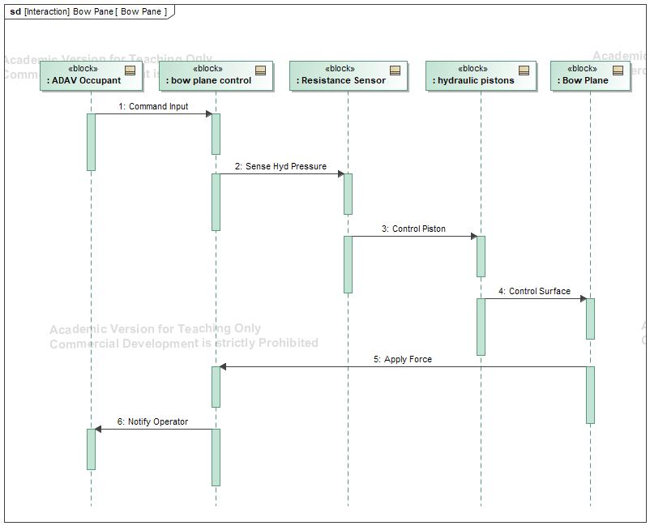

1. Bow Pane

## Description

The Bow Pane sequence diagram seen in Figure 1 shows the sequences by which the ADAV’s bow pane transitions between different operational phases.

**Messages**

| **No.** | **Message Name** | **Sender** | **Receiver** |
| --- | --- | --- | --- |
| 1 | 606376262.jpg Command Input | -294552874.jpg : ADAV Occupant | -294552874.jpg : bow plane control |
| 2 | 606376262.jpg Sense Hyd Pressure | -294552874.jpg : bow plane control | -294552874.jpg : Resistance Sensor |
| 3 | 606376262.jpg Control Piston | -294552874.jpg : Resistance Sensor | -294552874.jpg : hydraulic pistons |
| 4 | 606376262.jpg Control Surface | -294552874.jpg : hydraulic pistons | -294552874.jpg : Bow Plane |
| 5 | 606376262.jpg Apply Force | -294552874.jpg : Bow Plane | -294552874.jpg : bow plane control |
| 6 | 606376262.jpg Notify Operator | -294552874.jpg : bow plane control | -294552874.jpg : ADAV Occupant |

# Central Tire Inflation System Diagram

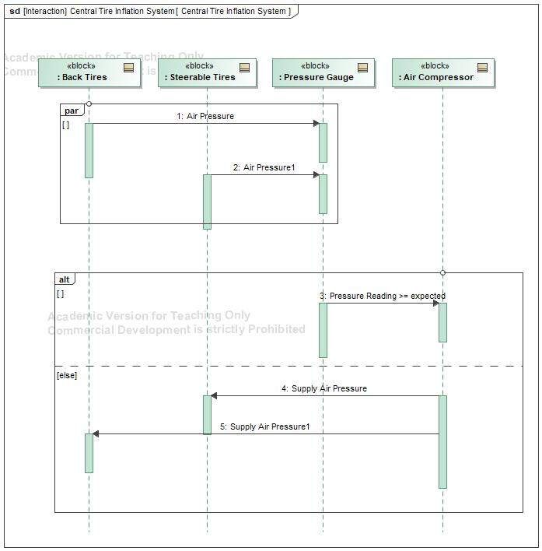

1. Central Tire Inflation System

## Description

The Central Tire Inflation System sequence diagram seen in Figure 2 shows the sequences by which the ADAV’s central tire inflation system transitions between different operational phases.

**Messages**

| **No.** | **Message Name** | **Sender** | **Receiver** |
| --- | --- | --- | --- |
| 1 | 606376262.jpg Air Pressure | -294552874.jpg : Back Tires | -294552874.jpg : Pressure Gauge |
| 2 | 606376262.jpg Air Pressure1 | -294552874.jpg : Steerable Tires | -294552874.jpg : Pressure Gauge |
| 3 | 606376262.jpg Pressure Reading >= expected | -294552874.jpg : Pressure Gauge | -294552874.jpg : Air Compressor |
| 4 | 606376262.jpg Supply Air Pressure | -294552874.jpg : Air Compressor | -294552874.jpg : Steerable Tires |
| 5 | 606376262.jpg Supply Air Pressure1 | -294552874.jpg : Air Compressor | -294552874.jpg : Back Tires |

# Climate Control Diagram

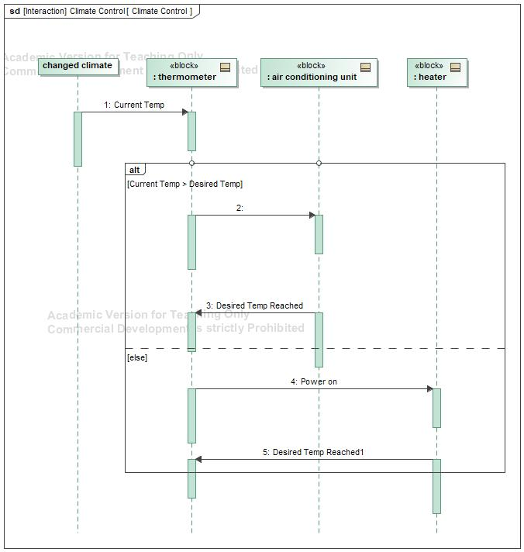

1. Climate Control

## Description

The Climate Control sequence diagram seen in Figure 3 shows the sequences by which the ADAV’s climate control system transitions between different operational phases.

**Messages**

| **No.** | **Message Name** | **Sender** | **Receiver** |
| --- | --- | --- | --- |
| 1 | 606376262.jpg Current Temp | -1603566318.jpg changed climate : | -294552874.jpg : thermometer |
| 2 | 606376262.jpg | -294552874.jpg : thermometer | -294552874.jpg : air conditioning unit |
| 3 | 606376262.jpg Desired Temp Reached | -294552874.jpg : air conditioning unit | -294552874.jpg : thermometer |
| 4 | 606376262.jpg Power on | -294552874.jpg : thermometer | -294552874.jpg : heater |
| 5 | 606376262.jpg Desired Temp Reached1 | -294552874.jpg : heater | -294552874.jpg : thermometer |

# Digital Camera Diagram

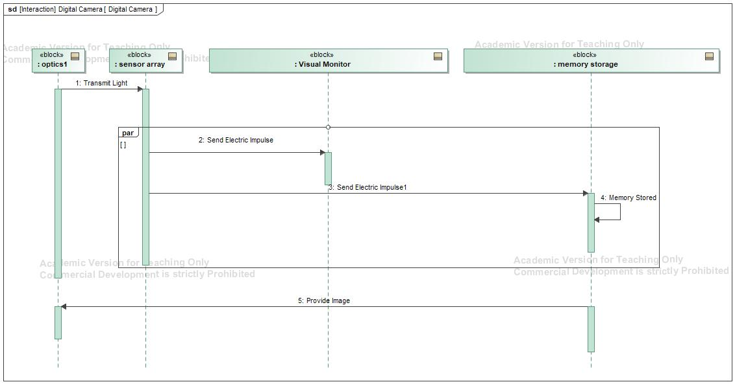

1. Digital Camera

## Description

The Digital Camera sequence diagram seen in Figure 4 shows the sequences by which the ADAV’s digital camera system transitions between different operational phases.

**Messages**

| **No.** | **Message Name** | **Sender** | **Receiver** |
| --- | --- | --- | --- |
| 1 | 606376262.jpg Transmit Light | -294552874.jpg : optics1 | -294552874.jpg : sensor array |
| 2 | 606376262.jpg Send Electric Impulse | -294552874.jpg : sensor array | -294552874.jpg : Visual Monitor |
| 3 | 606376262.jpg Send Electric Impulse1 | -294552874.jpg : sensor array | -294552874.jpg : memory storage |
| 4 | 606376262.jpg Memory Stored | -294552874.jpg : memory storage | -294552874.jpg : memory storage |
| 5 | 606376262.jpg Provide Image | -294552874.jpg : memory storage | -294552874.jpg : optics1 |

# Positioning Diagram

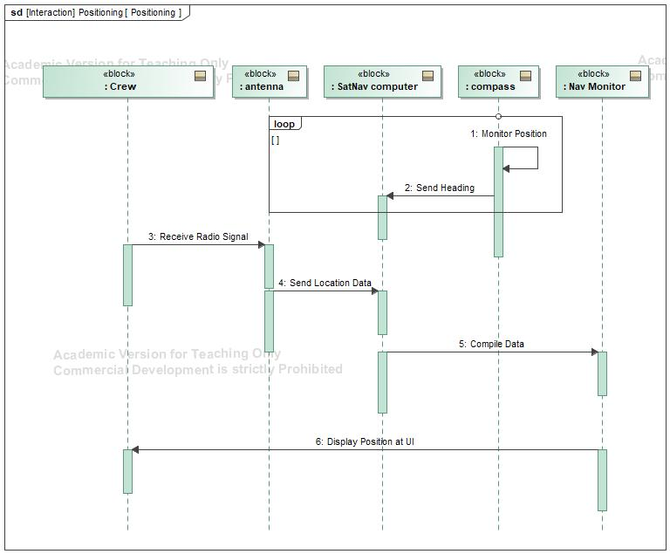

1. Positioning

## Description

The Positioning sequence diagram seen in Figure 5 shows the sequences by which the ADAV’s positioning system transitions between different operational phases.

**Messages**

| **No.** | **Message Name** | **Sender** | **Receiver** |
| --- | --- | --- | --- |
| 1 | 606376262.jpg Monitor Position | -294552874.jpg : compass | -294552874.jpg : compass |
| 2 | 606376262.jpg Send Heading | -294552874.jpg : compass | -294552874.jpg : SatNav computer |
| 3 | 606376262.jpg Receive Radio Signal | -294552874.jpg : Crew | -294552874.jpg : antenna |
| 4 | 606376262.jpg Send Location Data | -294552874.jpg : antenna | -294552874.jpg : SatNav computer |
| 5 | 606376262.jpg Compile Data | -294552874.jpg : SatNav computer | -294552874.jpg : Nav Monitor |
| 6 | 606376262.jpg Display Position at UI | -294552874.jpg : Nav Monitor | -294552874.jpg : Crew |

# UHF/VHF Radio Diagram

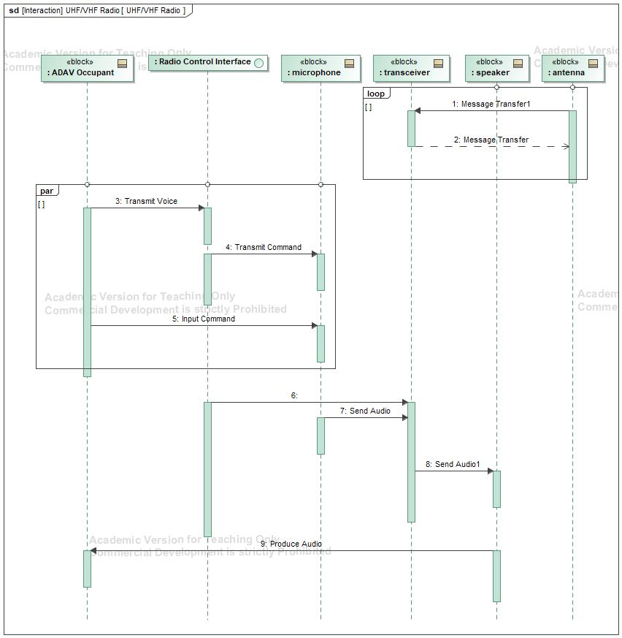

1. UHF/VHF Radio

## Description

The UHF/VHF sequence diagram seen in Figure 6 shows the sequences by which the ADAV’s UHF/VHF radio system transitions between different operational phases.

**Messages**

| **No.** | **Message Name** | **Sender** | **Receiver** |
| --- | --- | --- | --- |
| 1 | 606376262.jpg Message Transfer1 | -294552874.jpg : antenna | -294552874.jpg : transceiver |
| 2 | -650880544.jpg Message Transfer | -294552874.jpg : transceiver | -294552874.jpg : antenna |
| 3 | 606376262.jpg Transmit Voice | -294552874.jpg : ADAV Occupant | -222455180.jpg : Radio Control Interface |
| 4 | 606376262.jpg Transmit Command | -222455180.jpg : Radio Control Interface | -294552874.jpg : microphone |
| 5 | 606376262.jpg Input Command | -294552874.jpg : ADAV Occupant | -294552874.jpg : microphone |
| 6 | 606376262.jpg | -222455180.jpg : Radio Control Interface | -294552874.jpg : transceiver |
| 7 | 606376262.jpg Send Audio | -294552874.jpg : microphone | -294552874.jpg : transceiver |
| 8 | 606376262.jpg Send Audio1 | -294552874.jpg : transceiver | -294552874.jpg : speaker |
| 9 | 606376262.jpg Produce Audio | -294552874.jpg : speaker | -294552874.jpg : ADAV Occupant |